 **LAB # 01**

**Lab Title:**

Ping and Traceroute Commands for generic and customized information

**Lab Objective:**

Objective of this lab is to make students understand the use of ping and traceroute commands of network for generic and customized information.

**Activity Outcomes:**

The student will understand the advantages of ping and traceroute commands.

**Introduction:**

Ping uses the Internet Control Message Protocol(ICMP) echo-request and echo-reply feature to test physical connectivity. Because ping reports on four attempts (by default in windows), it gives an indication the reliability of the connection. Look over the result and verify that the ping was successful. Was the ping successful? If not, report to the instructor.

**Activity-1(Solved):**

**Network Ping Command (Windows)**

1. C:\Users\Administrator>**ping google.com**

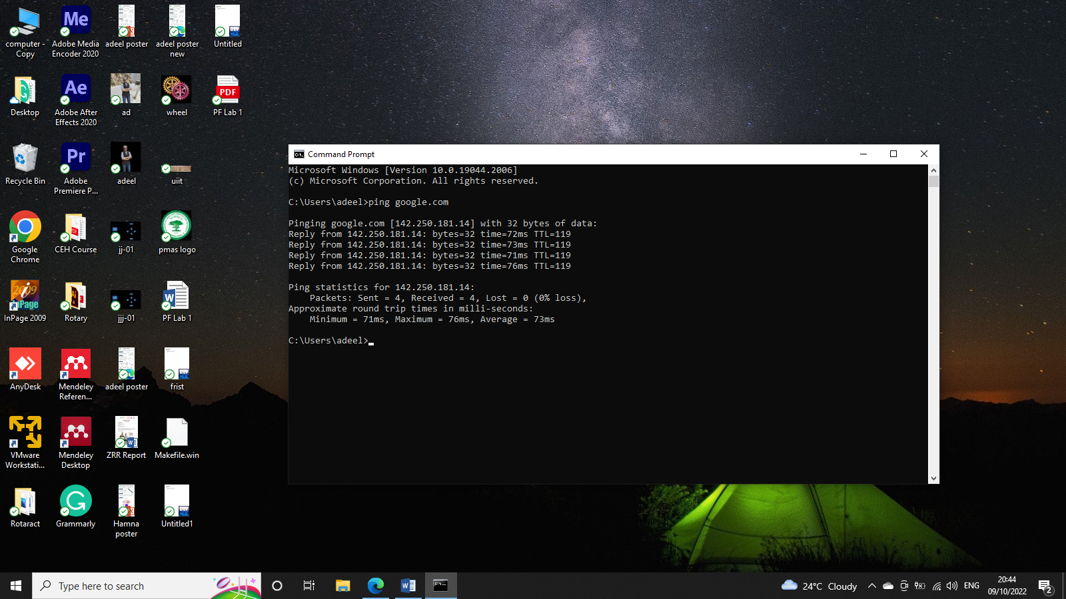

1. C:\Users\Administrator>**ping 216.58.208.78**

Pinging 216.58.208.78 with 32 bytes of data:

Reply from 216.58.208.78: bytes=32 time=38ms TTL=117

Reply from 216.58.208.78: bytes=32 time=36ms TTL=117

Reply from 216.58.208.78: bytes=32 time=36ms TTL=117

Reply from 216.58.208.78: bytes=32 time=36ms TTL=117

Ping statistics for 216.58.208.78:

Packets: Sent = 4, Received = 4, Lost = 0 (0% loss),

Approximate round trip times in milli-seconds:

Minimum = 36ms, Maximum = 38ms, Average = 36ms

1. C:\Users\Administrator>**ping -t google.com**  //-t for ping until stopped with ctrl^c

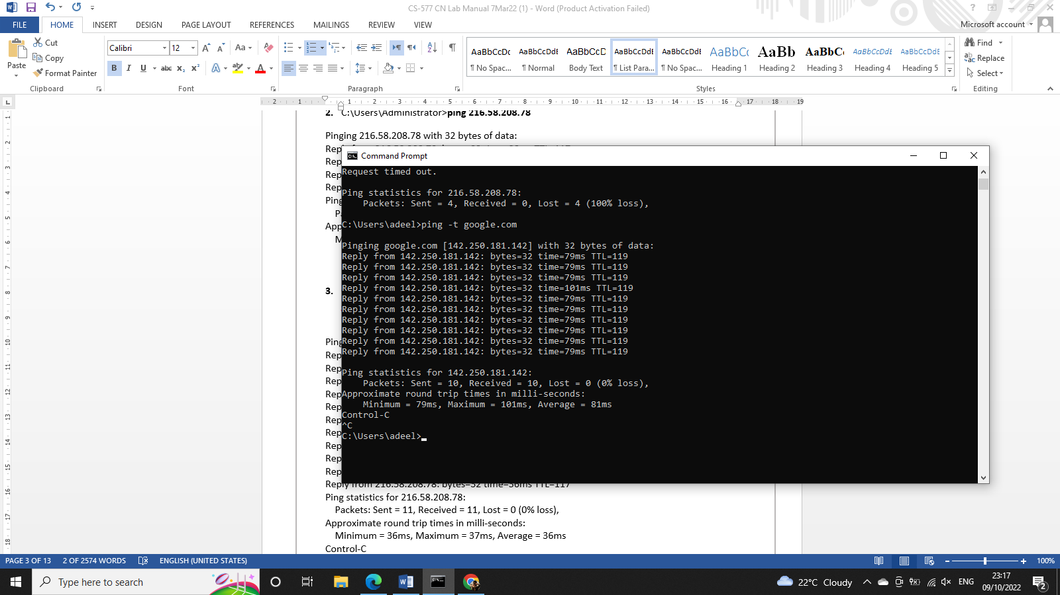

//-n 5 for 5 pings

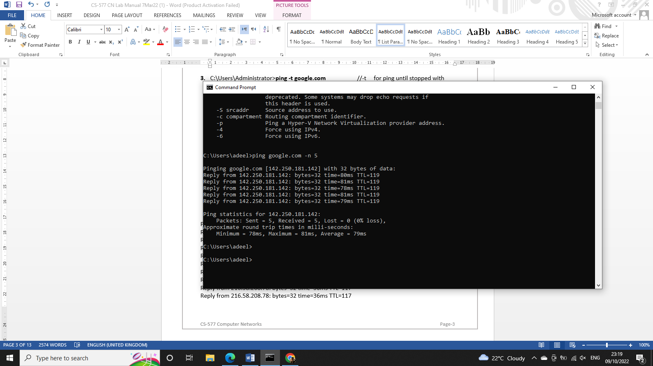

1. C:\Users\Administrator>**ping -l 200 google.com** //for change pkt size from default 32 to 200 upto 65500

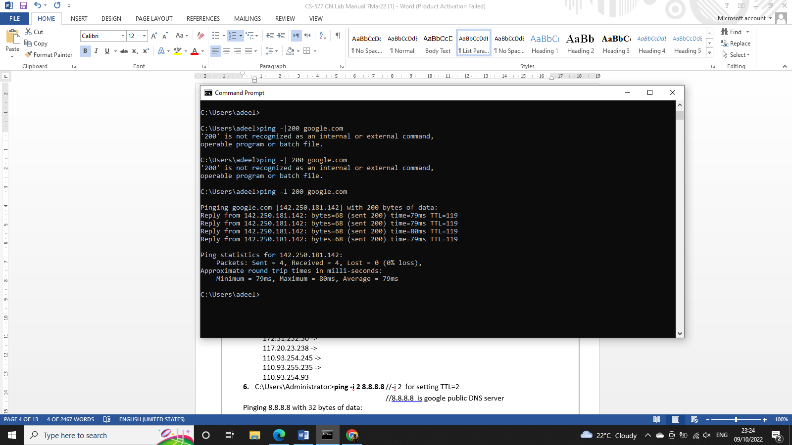

1. C:\Users\Administrator> **ping -i 2 8.8.8.8** //-i 2 for setting TTL=2

//8.8.8.8 is google public DNS server

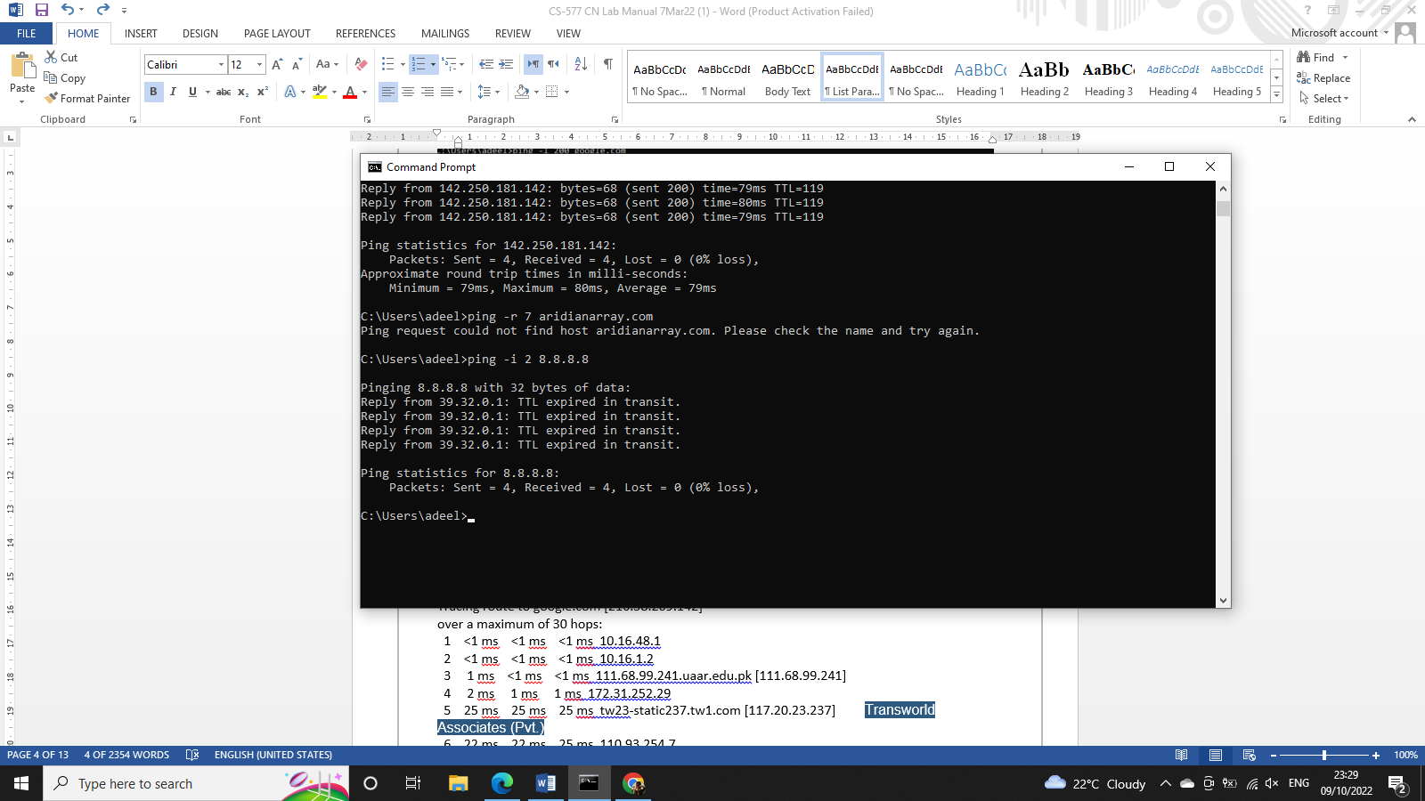

1. C:\Users\Administrator>**ping 127.0.0.1** //for loopback testing

/* The address 127.0.0.1 is reserved for loopback testing. If the ping is successful, then TCP/IP is properly installed and functioning on this computer*/

**Network Trace Route Command**

C:\Users\Administrator>**tracert google.com**

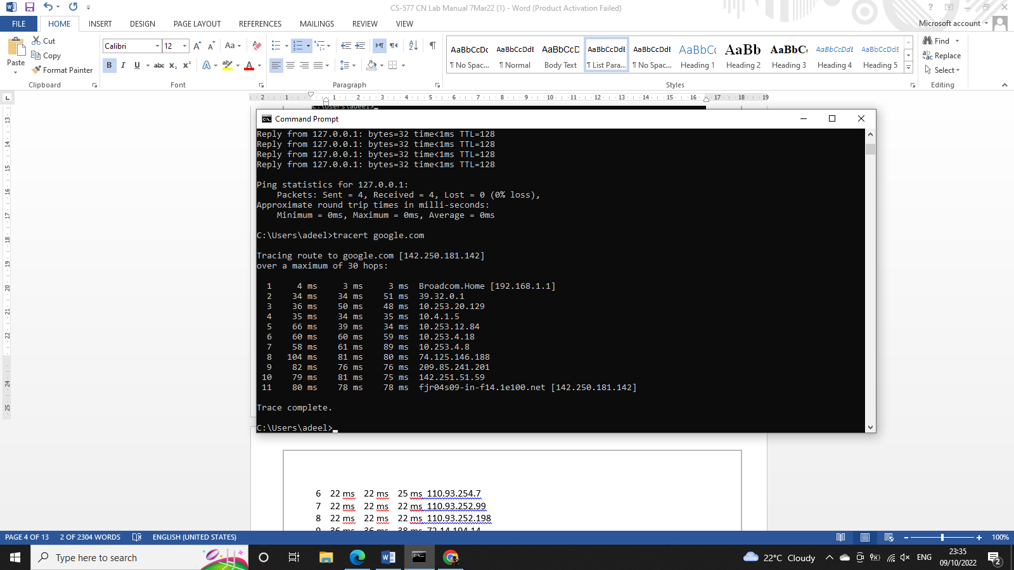

**Activity-2(Students will do theirself):**

**Find the equivalent of all above commands execute. Also paste the screen shots of the outputs.**